Beatty, Peter
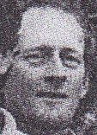
Graduated with BSc Forestry from ANU in 1975. Worked for Forests Department at Nannup and Kirup, in late 1970s. With CALM Vegetation and Tree Planting service in early 1990s. Worked at Manjimup Plant Propagation Centre in late 1990s. Later a Senior Consultation Forester at Forest Products Commission, Western Australia based at Manjimup. More than 35 years forestry experience.
A Director of Australian forest Growers. Secretary of IFA WA Division, IFA WA Forester of the year 2006.

